Physician Led, Resource Sensitive
Delivery System Reform

Wisconsin Health Improvement Zone – Care Improvement Dialogs:
(WHIZ-CIDs): A Report Out of Activity

The Center for Medical Practice Research and Education
at the
Wisconsin Medical Society

Tim Bartholow, MD, Chief Medical Officer

January 2012

Project Support: This work was supported in part by Physicians Foundation, Boston Massachusetts, ProAssurance, Birmingham Alabama, the physicians of Wisconsin, with in kind contributions of Wisconsin Education Association Trust, the Wisconsin Collaborative for Healthcare Quality, the Wisconsin Medical Society and the Wisconsin Medical Society Foundation.
Executive Summary
In the current environment of rising consumer costs, health care has become increasingly expensive and ultimately unaffordable for some patients. Even patients with employer-provided benefits are experiencing sluggish wage increases and higher contributions as employers cannot absorb these rising costs.
Physicians, in turn, are often faced with insufficient resources to address greater patient expectations, costlier technologies, safer but more expensive care and increasingly complex insurance paperwork.
To improve health care affordability, business and government leaders as well as consumers are demanding greater accountability from physicians in demonstrating health care quality and value and have pointed to claims databases as a way to achieve this goal. Physicians, in both training and personal expectation, are accustomed to self-evaluation but are wary of using complex, imprecise insurance billing in isolation to point the way to more affordable, higher quality medical care. Health care consumers who are earnestly seeking guidance in choosing a physician often find that insurance data is confusing and not specific to their own set of circumstances. These consumers, as well as purchasers pressured by unsustainable prices, must help physicians assess if this insurance data is helpful and safe before such evaluations are offered to the public as we all strive for the highest value health care.

The Imperative For Physicians, Purchasers And Consumers To Work Together To Best Understand How To Improve Care Delivery
To assess whether quality and cost of health care could be improved by investigating claims data alone, the Wisconsin Medical Society assembled doctors in higher cost specialties along with employers and consumers to review and discuss claims data. Under review were claims data for discrete episodes of care (i.e. healthcare services provided for a specific condition during a set time period) within the designated specialties. Our examination revealed that while the insurance data showed variations in cost, it was not readily apparent why these variations occurred. The data results also neither affirmed nor challenged the appropriateness of the care.
Several key findings were discovered in the analysis of these higher cost specialties that included orthopedics, cardiology, behavioral health and gastroenterology. While the specialist cost was not more than 10% of the total standard cost, the specialists and primary care doctors were responsible for authorizing as much as 70-80% of the total cost. Further analysis revealed that the difference between the presumed high quality/low cost provider and the high quality/ high cost provider was at least 30 % of the average cost per episode.
Despite learning valuable information about claims data in the selected specialties, the participants agreed that the results presented significant challenges for patients who might wish to use insurance data to select a physician. Specifically, the review of the claims data revealed:
- Claims data were void of clinical outcomes
- Claims-based risk adjustment were not validated by clinical risk adjustment
- Physician care attribution occasionally assigned to the wrong physician, and no attribution available to a team of doctors
- Data entry errors can be large and have uncertain effects or be unrecognized in the analysis
Our data study groups agreed that claims data alone was insufficient to instigate a change in practice, especially one which may impact the care of patients. This conclusion was reached principally because some of the most important features of care quality cannot be evaluated when claims data is viewed in the absence of clinical information (e.g. patient access to care, clinical risk, onset, outcomes, etc) from the medical record. Conducting this investigation with purchasers, consumers and physicians was a key feature of arriving at stronger mutual understandings and commitment to make a collective impact. From this collaboration, a new model of clinical decision making was described that combined resource use, clinical registry and shared decision making that leverages claims data to enhance the value of health care.
Despite the concerns raised by the group, there are exceptionally important lessons that can be learned from the claims data review. Key directives agreed upon by our reviewers include:
- Employer representatives and consumers working directly with practicing physicians in state and national specialty leadership to develop a path to higher value health care.
- A need for physicians to be more aware of the relative cost of an episode of care. They also need to be more aware of the relative costs of resources, where two or more equally suitable options exist so that the physician can make the highest value decision.
- The responsibility of physicians to advance appropriate use criteria (AUC) (e.g. treatment guidelines aided by computer decision support tools) to more accurately discern between patients who will and will not benefit from a considered procedure.
- Where a patient is thought to be appropriate for a procedure or investigation, physicians need to reduce variation in resource use between physicians to accomplish an excellent outcome.
- Consumers must be a partner in keeping themselves well.

Mixed Results Of Opportunity And Misconception Still Offer The Potential To Enhance The Value Of Care
These results do suggest that physicians can positively use claims data to review resource use and identify opportunities to enhance the value of care. The significant variations seen in these results however, are not sufficiently discrete for physicians to make substantive changes in practice especially when patient safety and mortality are at risk. Yet, when physicians have these data available, they should use this information to make cost sensitive decisions. A lack of awareness of these findings may put some patients at risk for less affordable care or eliminate access to care solely as a consequence of higher cost.
However appealing, if these data are presented to the public, data which are confusing to physicians, it remains unproven whether patients will be helped or further confused by tools designed to classify individual physicians with “quality” or “efficiency” metrics. Evaluating such data also creates additional questions:
- Will such data only serve to raise questions about all patient physician relationships at a time when we don’t have enough doctors for an aging population?
- Do such evaluations adequately reflect the reality of team-based care?
- Can the data be made sufficiently reliable for consumer decision making to earn the trust of prospective publishers and ultimately of the consumer?
If these questions cannot be satisfactorily answered, hasty presentation of this data could risk the public’s trust for a generation at a time when purchasers, consumers, and physicians together desperately need to improve the cost and safety of care. However, it is no longer acceptable that the physician practice without being constantly aware of the resource impact of their decisions – to forget this is to risk access of care for many.
These mixed results of opportunity and misconception and the diminishing affordability of care strongly suggest that physicians or their agents need to be proactive in improving the affordability of care by learning what they can from claims data. These efforts may have significant implications on the development of a value metric for Medicare in 2012 and for all of us as consumers who need to use “value” assessments while seeking a physician to care for ourselves or our loved one. Finally, in combination with clinical registry data, resource use data in a shared decision making platform evolves a powerful new path for better value based, patient centered choices in health care.
Introduction
Health care costs as of 2010 were 17.9% of our gross domestic product (GDP) in the U.S. and as they continue to increase, health care has become unaffordable for many individuals. Physicians, whose patients need but increasingly cannot afford care, are asking what their role is in fixing the problem.
To better understand the impact of doctors on the cost of care and to address the accessibility of appropriate and affordable care, a group of physicians, employers and consumers volunteered to seek solutions for higher value care in a claims data base containing over 60% of Wisconsin’s residents. Following their review of the claims, data study groups made observations and recommendations and then developed actionable next steps.

Economics Of Health Care
The growth in health care spending in the United States since 1980 has dramatically outpaced other industrialized countries. The average spending in the U.S. of $7538 per capita is more than double the median of $2995, and rises at a faster rate than others, as reported by the Organization for Economic Cooperation and Development (OECD). These expenses add costs of production to American manufactured products and services and these extra expenditures jeopardize jobs, many of which are the source of employer sponsored health care.
Even more compelling than the greater proportion of GDP dedicated to American health care is the increase in healthcare premiums and workers’ contributions to premiums. As recently reported in a 2011 survey by the Kaiser Family Foundation and Health Research Educational Trust (Kaiser/HRET), in the last 12 years, health insurance premiums have risen 160% and worker’s contributions to premiums has risen 168%, while wages increased by only 50% and overall inflation by 38% . The often difficult choice made by many employers to switch to high deductible health plans can be precarious for some people, like those with diabetes or asthma, for whom work attendance and productivity are dependent on access to advice and periodic treatment. This may also have devastating effects on personal finances as seen by the increase in proportion of personal bankruptcy directly related to medical expenses from 8% in 1980 to 46.2% in 2001 to 62.1% by 2007. Given the current economic climate, this number is not likely to improve soon.
The strain of international competition and domestic health care costs has forced some domestic businesses to stop offering insurance or to increase the out of pocket exposure to the employee/patient. The percentage of firms offering insurance has declined by around 10% over the last decade and of those that offer insurance, the proportion of high deductible plans rises quickly (as high as 28% in companies with 3-199 workers).
The challenges experienced in employer-based insurance are also being felt in government-supported care. Medicare Part B faces the possibility of 27.4% cut to physicians as a consequence of the Sustainable Growth Rate formula. Also noted in the May 2011 Trustee’s Report that the Medicare Part A Trust Fund (that makes payments predominantly to hospitals) in 2008 began showing expenses that exceeded revenues. With the report predicting that the existing trust fund will be exhausted in 2024, House Speaker Boehner (R., Ohio) offered the following: "The Trustees' report makes it clear that if we do nothing, Medicare will not be able to pay promised benefits to American seniors—and sooner than we thought."
Without profound, urgent change, many people are poised to needlessly lose access to care. In an effort to characterize how doctors impact the cost of care, a group of physicians, employers and consumers volunteered to study claims data to seek solutions. The findings were, in turn, both revealing and ambiguous and pointed toward a few key directives.

The Data: The Wisconsin Health Information Organization (WHIO) Data Mart
In 1967, healthcare researcher John E. Wennberg stated in his research with Dartmouth’s Center for the Evaluative Clinical Sciences:
“..when we looked at the data, we found tremendous variation in every aspect of healthcare delivery, even among communities served by academic medical centers. We found the same thing when we compared healthcare in the Boston and New Haven communities served by some of the finest academic medical centers in the world. The basic premise-that medicine was driven by science and by physicians capable of making clinical decisions based on well-established fact and theory-was simply incompatible with the data we saw.”
In 2005, the Wisconsin Health Information Organization (WHIO) was formed to reveal how health care dollars were being spent in Wisconsin. A claims database was developed comprising a rolling 27 months of data with updates published about every 6 months. The first such database was prepared for analysis in October of 2008. The claims data came from diverse and sometimes unlikely collaborator stakeholders (Appendix A). WHIO governance includes the broad categories of purchasers, payers, providers and the State of Wisconsin.
The WHIO data mart has now published the following data marts (see Table 1):

Table 1: Data Mart Versions and Claims Totals
Version | DMV 1 | DMV 2 | DMV 3 | DMV 4 | DMV 5 | DMV 6
Release Date | December 2008 | August 2009 | April 2010 | October 2010 | April 2011 | Nov 2011
Number of Residents out of 5.6 M Residents | 1.52 million | 1.63 million | 2.6 million | 3.4 million | 3.7 million | 3.8 million
Medicaid Claims | n/a | n/a | 550,000 ( Fee for Service, no HMO) | 1.2 million | 1.2 million | 1.1 million
Total Standard Cost | $7.6 billion | $9.6 billion | $18.65 billion | $28.9 billion | $29.9 billion | $34 billion

Among the 15 states that have collected or are collecting multi- or all-payer claims data bases, only Wisconsin and Washington State have voluntary, multi-stakeholder, private-public partnerships. Wisconsin has the nation’s largest discrete state-based claims data base which has allowed equal and unprecedented access for each of the stakeholder categories (payers, providers, purchasers and The State of Wisconsin). Physicians have never before had access to such data, and have not had the opportunity to identify with other stakeholders the strengths and weaknesses of this data.

Additional WHIO Data Base Details:
- Contains commercial claims including administrative services only (ASO) claims which require employer permission before aggregation.
- Only Medicare Advantage claims submitted by insurer data contributors are available
  - Number represents approximately 200,000 of the 907,000 (2010) Wisconsin Medicare lives.
  - Medicare is actively exploring how to share data while protecting privacy.
- Only fee for service (FFS) Medicaid claims were available with DMV3, and the remainder of Medicaid became available with the addition of HMO Medicaid by DMV4 and thereafter
  - Medicaid claims are comprised of both long term care expenditures and acute care expenditures.

Pricing Comparisons
“Standard Pricing” is the surrogate pricing mechanism developed by OptumInsight (formerly Ingenix) that is used to adjust pricing based specific criteria and is roughly the prevailing rate across a discrete region. Use of standard pricing is intended to allow comparison of resources used across regions, neutralizing contract price differences, while preserving the relative magnitude of expense attributed to a resource.
An important exception to this pricing methodology is facility outpatient services. For these services, the amounts billed and paid are stated to be so variable that no specific standard price can consistently represent a likely price for an outpatient facility service on any campus. “Facility Outpatient” is therefore assigned a “Standard Price” that is a percent of billed charges. Therefore, comparing bundles or episodes with a large proportion of facility outpatient services may not result in a fair or reliable comparison.
Medicaid rates are publically stated and the Medicaid data contained in the WHIO data mart uses publically stated paid amount for “standard cost.”

Data Integrity
Among 270 million claims lines in DMV6, it is not surprising that several large errors were identified. Distributed across large populations, these inaccuracies may be negligible, but they may be misleading if they are assigned to an individual clinic or a physician or in the evaluation of a category of an uncommon illness. Even meeting six sigma goals of 2.3 or fewer defects per million suggests that in 270 million claims lines, each claim containing several elements, there realistically could be a few thousand errors of uncertain magnitude.
The full effect of these data inaccuracies is not known, but their incomplete characterization makes all stakeholders cautious in reporting at a granular level. Quality Assurance of the original claims and the aggregated claims warehouse is an important element of any claims data base used for these purposes.

Where Is Wisconsin Spending Its Health Care Dollars?
As we studied data, the most recent version of the WHIO data mart was used, which for this study was Data mart Version 4 (DMV4). In DMV4, the standard dollars spent in Major Practice Categories (MPCs) are shown in Figure 1. This analysis guided which specialty areas we would engage. Designating MPCs is an attempt to classify the various services that contribute to bundles generally focused on a particular specialty with the support of other specialties. MPCs are an OptumInsight convention and are not a medical specialty. For instance, there is no specific MPC for several specialties including emergency medicine, pathology and radiology. Instead, the standard costs of services from these specialties are aggregated into episode costs that are assigned to the conventional MPCs seen in Figure 1.
Figure 1

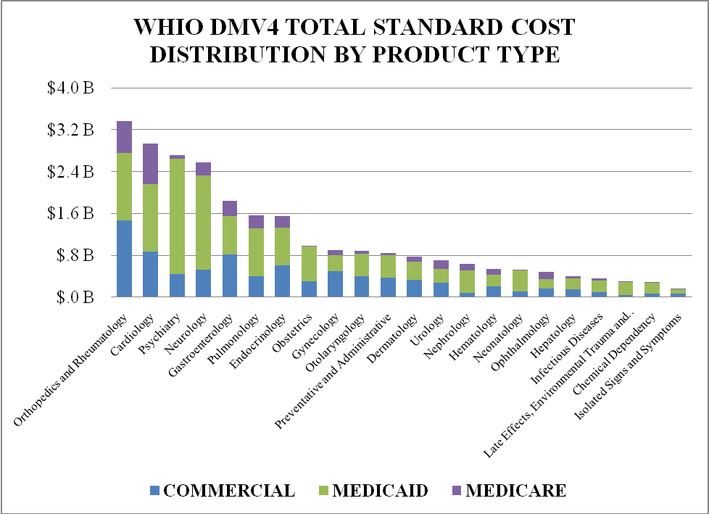
As seen in Figure 2, this review demonstrates that the five most expensive MPCs describe 53% of Total Standard Cost of the entire WHIO data mart in DMV 4.
Figure 2
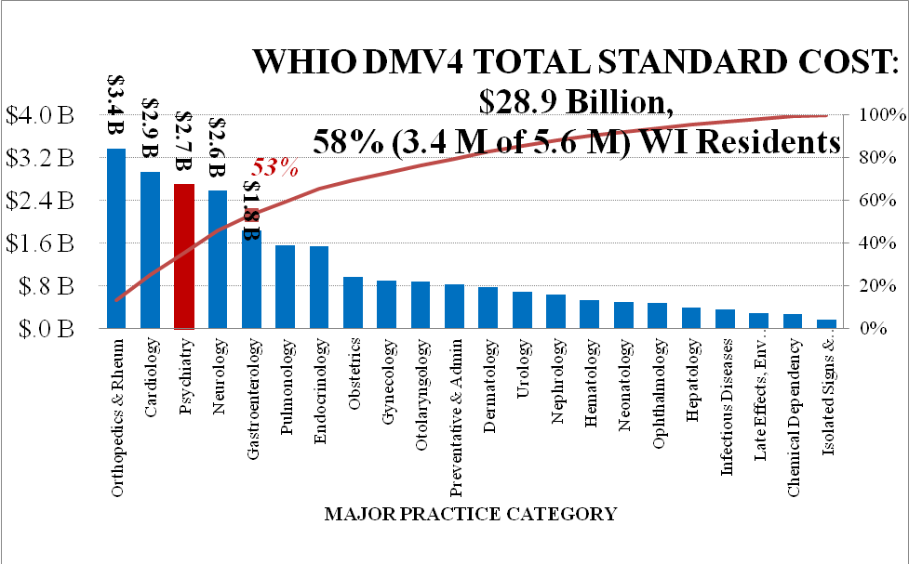

Physicians, Employers, and Consumers Study Claims Data Together
As the crisis of patient access to physicians continues to grow, doctors reached out to employers and consumers to identify solutions suggested by this new data source. Data study teams evaluated the most expensive areas including orthopedics, cardiology, behavioral health and gastroenterology.
In the spring of 2010, teams were assembled that would include state physician leadership in the respective medical specialty, primary care doctors and employer representatives. In the spring of 2011, consumer groups were added to these teams.
These data study team investigations in 2010 and 2011 included no fewer than 9 one hour teleconferences reviewing new installments of data analysis, several hours of analysis with a specialty leader and a data analyst, and many undocumented hours of specialists, employer and/or consumer guidance concerning development and strategy.
These calls were interactive dialogs focusing on the data analyzed from the WHIO data base and guided by the interest of the group with a focus on opportunity for impact. These calls were led by Tim Bartholow, MD, Chief Medical Officer of the Wisconsin Medical Society with the assistance of the respective specialty leader. The following ground rules were stated for all sessions:
- Candor with respect; let’s discuss elephants in the room
- Right for everyone to be heard; careful not to monopolize
- Right to decline to speak
- Orientation recorded but subsequent sessions are not recorded to allow frank discussion
Each member was free to ask questions of the others and they did; both inside of these calls as well as ultimately outside of these calls.
These investigations would begin with the selection of an Episode Treatment Group (ETG) for study from within the respective MPC. The ETG selected was to have large dollar impact, be identifiable to clinicians as a discrete clinical area, and be suspected to be an area of clinical variation by physicians’ empiric experience.

Doctors, Employers And Consumers Share Concerns And Opportunities
Variation like that noted by Wennberg in the Dartmouth Atlas may be present in Wisconsin in the diagnosis and treatment of several conditions that will be described below. Each contributing member had valid concerns about potential variation.
Employers were concerned that observed variation was a result of not using available medical evidence and that this variation may represent lost value and/or unnecessary cost. Physicians acknowledged the variation, but suggested that other factors required study before concluding that this variation was a consequence of suboptimal physician choices. These other potential factors included:
- Attribution to the proper physician
- Claims-based risk adjustment, not clinically based risk adjustment
- Clinical outcomes data to assess what resources lead to better outcomes
- Claims data entry errors

Several observations were made during the discussions:
- Differences in beliefs about public reporting for employer/purchasers, consumers and physicians.
- Consumers seek reliable information on accessing care, but find that much of what is available is confusing.
- Among all opportunities to improve quality, the functional loss of access to the patient’s doctor is one of the most serious threats to “quality.” Physicians observed that employers were not focused on price alone, but were keenly interested in quality.
- Participants agreed that higher quality in some cases may result in more affordable care.
- Expensive care can result in less access to care for more individuals.
- In making literal life and death decisions, the physicians’ greatest concern in considering a change of practice is the confidence that an alternative choice is of equal or better safety for patients.
- All agreed on the importance of identifying and reducing the sources of variation in care where this variation did not add value. Dollars spent which do not add value only serve to make care unaffordable for many or inaccessible for some.
At the end of the 2010 study sessions, participants suggested four conclusions from their study and deliberations:
- It is each individual citizen’s duty to maintain their best health with their chosen health care team. Where individuals do not act to avoid preventable illness, it is a cost to others in their community.
- For individuals who are not well, and for whom expensive diagnostics and procedures may be appropriate, physicians should use guidelines or “appropriate use criteria” to discern between those patients who will and will not likely benefit from a considered procedure.
- In circumstances in which a patient needs an expensive diagnostic or procedure, physicians should seek ways to reduce intra-physician variation in the accomplishment of that study or treatment.
- The patient needs to more actively share decisions about their care.

Episode Treatment Groups Vs. CPT code
OptumInsight has identified about 600 Episode Treatment Groups (ETGs) that bundle costs of the Facility Inpatient, Facility Outpatient, Professional (including doctors and others), Pharmacy, and Ancillary types of service.
Physicians, however, are not accustomed to thinking about ETGs like “Joint Degeneration. Localized, of the Knee and Lower Leg, with Surgery.” Rather, they are accustomed to thinking about the care associated with a particular CPT code. What physicians need to increasingly think about is who benefits most from the procedure, designated by a CPT code, and the other parts of care and the expense that surrounds that procedure. For some of the analysis that follows, care was identified in Episode Treatment Groups and for other analysis a CPT code and all of the episodes costs that were associated with that code were identified. Some of the overlap is described in Appendix B.
Also of note was that not all episodes were eligible for review based on necessary multiple selection criteria (see Appendix C). Using the established selection criteria, only 11% of episodes were used for evaluation.
Clearly one of the most relevant findings from these studies was that for some of the most common episodes, the respective specialist was not more than 10% of the total standard cost.

Table 2: Specialist Review of common ETGs
Episode Treatment Group: | Ischemic Heart Disease with Angioplasty | Inflammation of the Esophagus, without Surgery | Joint Degeneration, localized - Knee and Lower Leg, with Surgery | Mood Disorder, Depressed
Total Episode Standard Cost, DMV4 | $243 M | $195 M | $287 M | $499 M
Specialist | Cardiology | Gastroenterology | Orthopedic Surgery | Psychiatry
Total $ | $23 M | $10 M | $28 M | $23 M
% of Episode $ | 9.5% | 5.1% | 9.8% | 4.6%
Facility, Inpatient and Outpatient
% of Episode | 77% | 39% | 80% | 30%
Primary Care
% of Episode | 1% | 7% | 1% | 5%
Prescription Drugs
% of Episode | 2% | 32% | 1% | 35%

Data Investigation Teams
The following summary offers high level findings for each of these four groups. Analysis are more rigorous in the more expensive and resource complex areas of orthopedics and cardiology. Solutions for behavioral health and gastroenterology quickly focused on pharmacy opportunities and analyses were more focused. Workforce issues with behavioral health in particular were acknowledged, but not fully explored in the claims data.

Orthopedics
OptumInsight created the MPC of “Orthopedics and Rheumatology,” the latter of which (rheumatologists) appear to contribute only about 1% to this category cost (although the biologic treatments and other choices ordered by rheumatologists add other costs and are likely to increase). Most of the cost in this MPC is primarily thought to be attributable to orthopedics.
Reviewing the costs at the highest level of type of service reveals the following distribution of total standard cost:
Figure 3
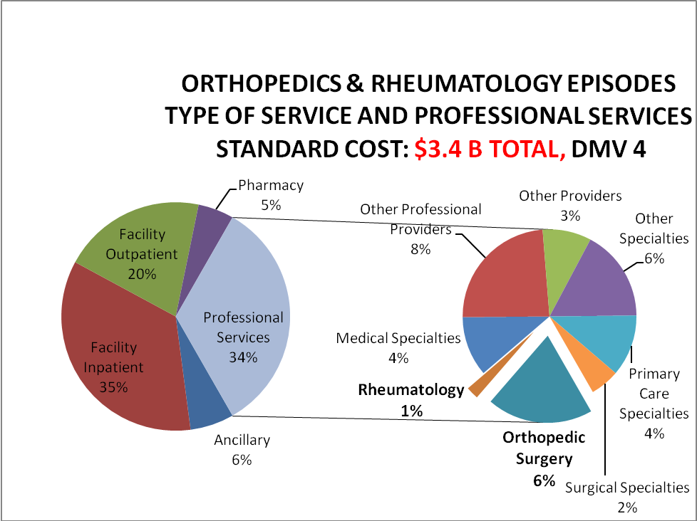
Key Findings:
- Facilities appear to comprise 55% of this MPC that includes both operative and non-operative Orthopedics and Rheumatology.
- The right hand pie graph of Figure 9 represents proportions of the 34% of professional services, which includes specialists and several others. This figure represents both operative and non-operative Orthopedics and Rheumatology, for which the orthopedic surgeon is 6% of the bundle standard cost. When considering only operative orthopedic procedures, like Joint Degeneration, Localized, of the Knee and Lower Leg with Surgery, the orthopedic surgeon is near 10% of the bundle standard cost.
- Findings show that costs attributed to the orthopedic surgeon were less than 10% although physicians together, specialists and primary care, authorize what appear to be 70 if not 80 % of all bundle costs.

ETG Focus: Joint Degeneration
In January 2010, with WHIO DMV 2 data available, the focus group decided to study the ETG “Joint Degeneration, Localized, of the Knee and Lower Leg, With Surgery” (see Appendix D) as it was determined that these would contain a high volume of discrete, relatively similar procedures, including knee replacement and knee arthroplasty.
Our employer representative on this data study group revealed that for one organization, accounting for age and changes in the size of the insured pool, that utilization had increased dramatically in less than 10 years.
Table 3: Sample Knee Replacement Costs
Year | Total Cost | Total Knee Replacement per 1000 employees
2000 | $ 997,690 | 0.46
2009 | $5,423,750 | 2.02

Employers acknowledge what has been documented nationally (see Table 3), that such growth or utilization and expense jeopardize affordability for employers or employees in this organization. Participants concluded that this increase was related to many factors including but not limited to patient selection, decrease in the number of complications for this procedure over the last decade, longer lasting implants and patient demand.
Results
In analyzing the variation of severity level 1 episodes data for knee replacement (CPT code 27447), the results demonstrates standardized costs with a mean of $27,254 with the first standard deviations below and above of $22,584 and $31,924 respectively (see Figure 4) . Compared to the mean cost, this $9,340 difference between standard deviations above and below represents 34.3% of the average cost of the bundle. Study group participants across specialties believed that reason for such variation could include but were not limited to differences in coding, patient choices, data entry, practice culture, physician choice or knowledge gap.

Figure 4
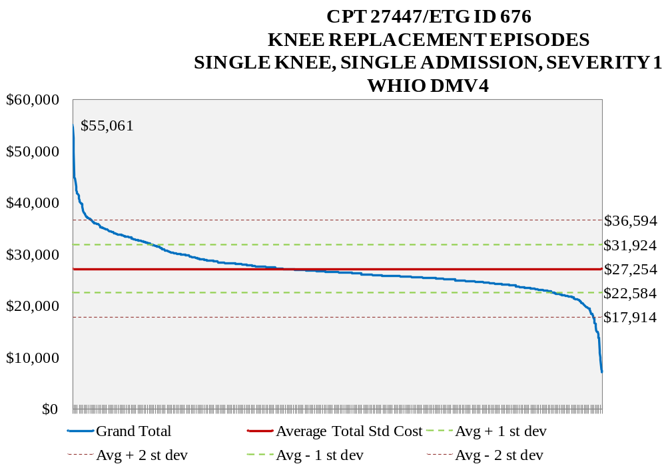
Study participants acknowledged the limitations to the data including but not limited to attribution, claims based risk which may not reflect clinical realities, the absence of outcomes, and data entry error.
Despite these data challenges, participants quickly identified some sources of variation over which orthopedists had control, including implants and other choices made in the resource intense environment of the operating theater. The group also studied severity level 2 and 3 episodes and determined that the mean of these ascending severity levels was not dramatically larger than the average cost in the preceding severity level, and similar variation between high and low cost episodes within each severity band was noted.
Because the inpatient facility standard cost was a large portion of CPT 27447 bundles (see Figure 5) , a comparison was made of the elements contributing to the aggregate bundle total standard cost at three high volume hospitals to identify alternative high value decisions that the physicians could make (see Figure 6) in the use of these inpatient resources.
These results suggest that the coding of services between hospitals is strikingly different from hospital to hospital despite the presumed similar clinical methods of achieving a knee replacement. Although this data are the most granular available for hospitalization in the WHIO data mart, this analysis did not reveal clear information to the participant orthopedic surgeons about alternate choices aimed at enhancing the value of care. The large categories of revenue code “other” or “Medical/Surgical Supplies/Devices – Other” are vague and do not provide sufficient detail for the clinician to compare their resource use choices to others at other institutions by analysis of claims data alone. The analysis does appear to indicate that inpatient facility resource use ordered by physicians must be part of any successful attempt to improve value. Further comparison between institutions would allow Wisconsin physicians to understand what mix of services brings highest value, but this will require more than analysis of claims data alone.
Figure 5: Type of Service for 27447—Arthroplasty, knee, condyle and plateau; medial and lateral compartments with or without patella resurfacing (total knee arthroplasty)
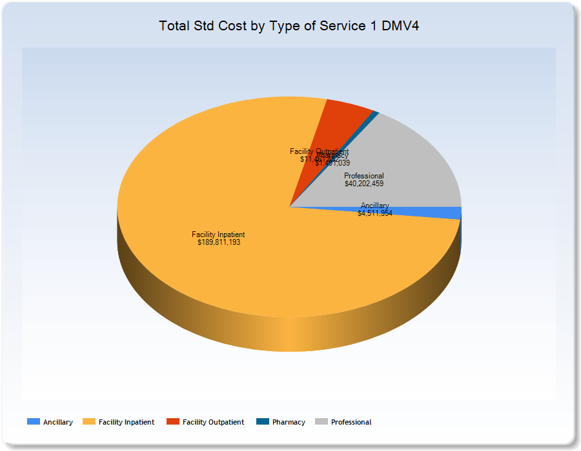
Figure 6
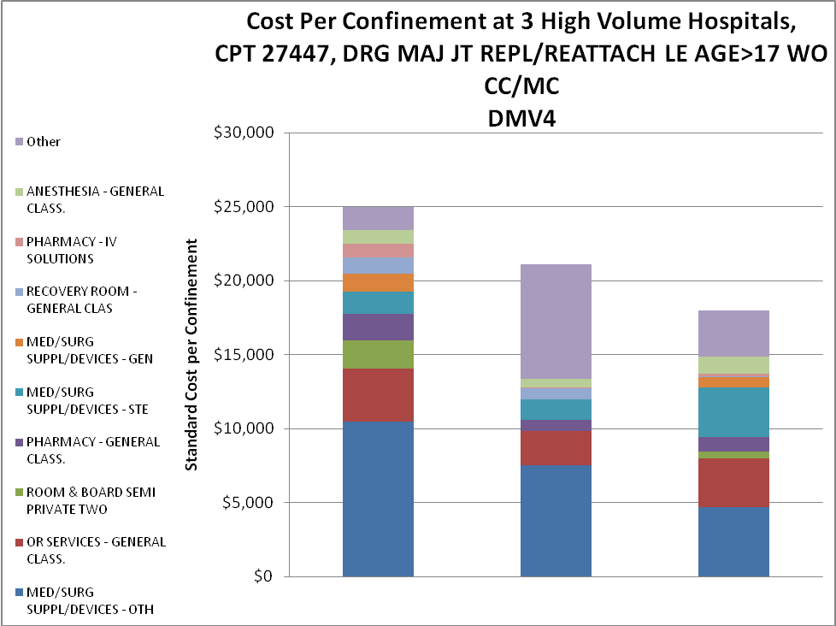

Length Of Stay
The orthopedic group studied length of stay in the WHIO DMV 4 for CPT 27447 (see Figure 7) and verified greater total standard cost for each additional day of hospitalization. For longer lengths of stay that are under DRG or similar case rates, these hospitalizations may result in payments from the payer which are less that than suggested by standard cost. These higher costs however would be attributed to a provider.
Figure 7
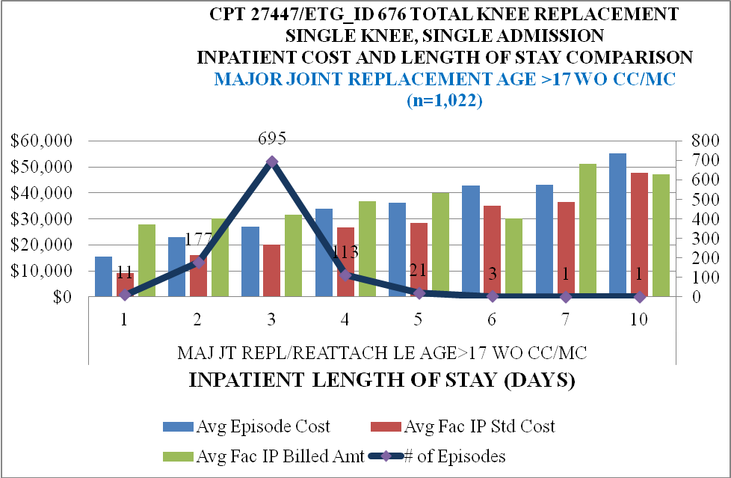
Analysis of results concluded that a three day length of stay was predominant. There was an unexplained finding in the inpatient (IP) billed amount being equal or less than the average total standard cost (Std Cost) at days 6 and 10.
Participants wondered if the day of operation late in the week, and the sometimes less intense physical therapy available over the weekend at some facilities would impact total standard cost. There may be some effect, but this appears to be limited to less than $1000 per procedure. (see Figure 8).

Figure 8: CPT 27447/ETG ID 676 – Knee Replacement Episodes, Single Knee, Single Admission, Severity Level 1, w/responsible provider, WHIO DMV4
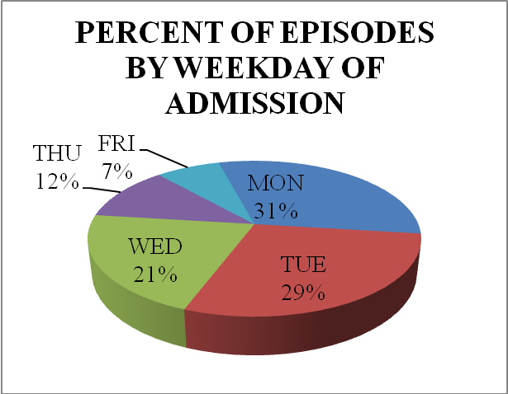
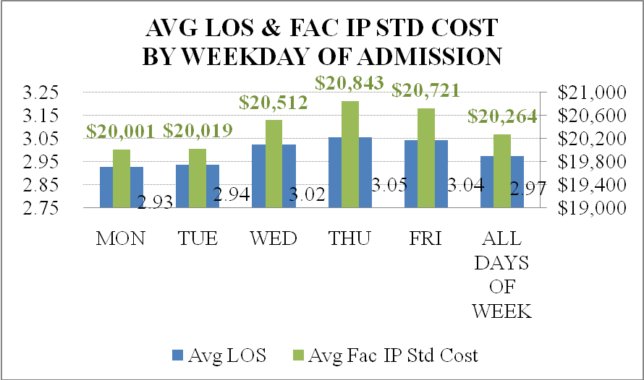
Orthopedic Conclusions
Following the claims data analysis, the Orthopedic Study Group reported the following observations and recommendations:
Observations
- Knee replacement total costs appear to be going up largely as a result of increases in utilization per thousand patients.
- AUC although not yet developed for knee replacement may be valuable to reduce variability in candidate selection if such variation exists.
- Orthopedic practice is experiencing greater patient expectations at a younger age in at least one purchaser’s experience.
- The engineering and durability of implants have improved even in the last 10 years.
- Knee replacement and post knee replacement care is better with lower complication rates and improved functional outcome status as seen in orthopedic literature.
- Physicians have limited access to hospital cost data which often leaves them unaware of the real costs of implants or other choices.
- Pre admission and post admission management have decreased length of stay across many environments.
- The largest variable costs appear to be incurred in the inpatient hospital setting (including but not limited to):
  - Implants, prostheses, other medical/surgical supplies
- Revenue code inpatient billing is not granular enough to determine the source(s) of variability between physicians at different institutions for inpatient resource choices.
- Detailed supply costs, including prostheses and implantable devices, are only available on itemization that accompanies hospital bill but are not in coding that leads to claims.
Recommendations
- Don’t open sterilized tools or disposables unless use is assured.
- Savings associated with reduced waste should not accrue to the insurer only.
- Reduce implant costs by:
  - Negotiating “price points" that allow multiple vendors to bring in their implants at this cost.
  - Limit implant vendors to only a few to secure the best price.
- Although getting physician buy-in may be challenging, attempt to reduce variability through:
  - Standardized surgical pans instead of extensive use of personalized special instruments
  - Single draping
  - Uniform pathways of best practice
- Utilize inpatient hospital management to aggressively manage medical issues and help avoid complications.
- When faced with making cost-significant choices in the most expensive area in which they work (i.e. the operating room), orthopedic surgeons would like to know the cost to the facility, the billed amount, the average commercial paid, the Medicaid and Medicare rates. This would allow them cost awareness as they are choosing between quality equivalent choices.
Following these discussions, the employer representative from this team was invited to the Orthopedic Quality Institute of the American College of Orthopedic Surgery in 2010, and again in 2011 as part of a growing conversation between employers and orthopedics around possible solutions to cost and utilization challenges. Participants believed the conversation between employers and physicians is crucial to identifying the path to improved value and affecting patient/employee behavior in accessing care. WHIO sponsored the Partnership for Health Care Payment Reform, a Wisconsin payment reform project, which has used WHIO data and some of the study group participants with the lessons learned to model a bundle for knee replacement.

Cardiology
Analysis of high volume ETGs by the Cardiology data study team identified that the ETG of hypertension (elevated blood pressure) was the most expensive and frequent ETG, but that analysis of “Ischemic Heart Disease, with Angioplasty” would provide a more discrete and homogeneous clinical activity to study.
As seen in Figure 9, the largest components of the ETG “Ischemic Heart Disease with Angioplasty” include facility fees that are approximately 75% of the total standard cost. Total professional fees were 13%, with the cardiologists ultimately accounting for slightly less than 10%.
Figure 9
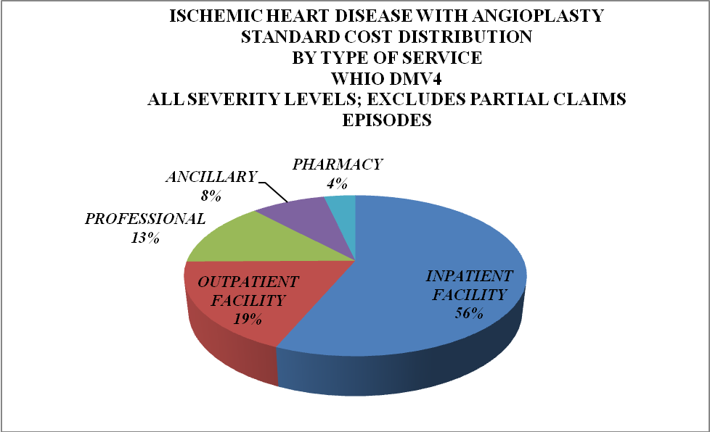

ETG Focus: Angioplasty
Episodes of Angioplasty, severity level 1, contained within WHIO DMV 4 were arranged most to least expensive and an average cost of $24,807 with one standard deviation below and above at $12,435 and $37,179 respectively, a difference of $24,744 or a variation compared to mean of 99.7% (see Figure 10). As with orthopedics, the cause of this variation could not be fully identified. Potential causes could include coding, data entry, patient preference, culture of the local practice, individual physician preferences, or knowledge gap.
Figure 10
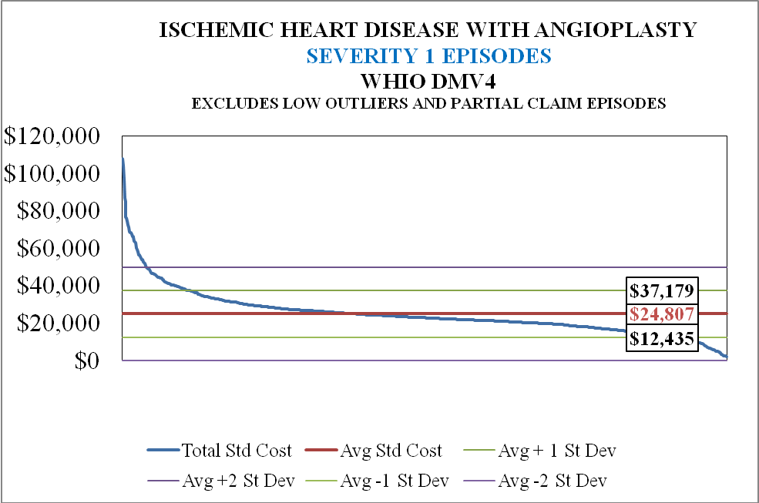

Results
Employer/purchasers were concerned that variation was a consequence of not following evidence based guidelines. This concern could neither be confirmed nor refuted from claims data. The clinicians acknowledged the variation and discussions followed about the American College of Cardiology’s decision support tools called AUC. These criteria discern between those who were likely and those who were less likely to benefit from a candidate procedure.

Delay To Clinical Evaluation That Cannot Be Reflected In Claims
The variation in the intensity of care for angioplasty with stenting may be caused by lapses of time to treatment including the time of symptom onset to the time of presentation to the door of the facility. Systems of care have worked diligently on controllable components of care to minimize the time between the door of the facility and angioplasty, known as “door to balloon time.” However, physicians have little control over a patient’s response to condition, the time taken to seek help and available transportation assets. Presenting to the emergency department later will result in more damage to the heart muscle, a more intense clinical treatment and an overall poorer outcome. When costs are observed across the state of Wisconsin, participants acknowledged that the available data was unable to describe whether there was a systematic delay in the time when patients either called for help or in the transport time that was available. Clearly, long delays in opening the occluded coronary artery would lead to a clinically more difficult and expensive course and sadly poorer outcome. In Wisconsin, there are some communities which have resources and have made a priority of coordinating public messaging and transportation to optimize for a good result. None of this information is discoverable in claims and measures of transport time and its impact on outcome would have to be assessed with different tools.

Facility Inpatient And Facility Outpatient Have Greatest Cost Impact
The data revealed that facility inpatient and facility outpatient resources comprised 75% of expenses in DMV4 for angioplasty with percutaneous intervention (i.e. stenting). Five high volume hospitals and the physicians who practice at those facilities were studied (see Figure 11) to determine what contributed to the large costs of “Facility Inpatient” and “Facility Outpatient.” Although costs for professional services was relatively similar across all five hospitals, a significant variation was seen in the facility inpatient costs as well as less pronounced variations among the other costs including outpatient and ancillary costs.

Figure 11
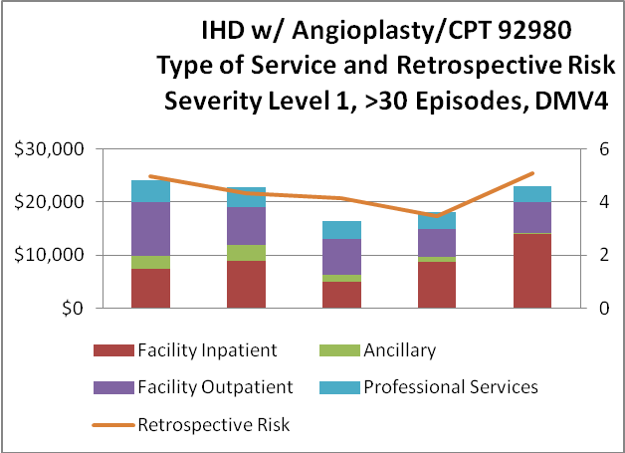

In a separate study of four high volume facilities (see Figure 12), the various components of “Facility” billing were identified with the goal of providing the physician with detail on how to provide high quality care with the least amount of resources. Unfortunately, these amalgamated categories into which physicians’ choices are coded do not allow a group of physicians to know which specific choices contributed to the cost without adding value or by how much each choice advanced the total cost. The very physicians who are requesting these items need to know how their choices compare to those choices of other judicious practitioners at other institutions. As we can see above, “Professional Services” appear to be about the same whether the total cost is most or least. The inability to know which resources led to what incremental costs prevents the physician from knowing how their choices impact this global facility cost, the most expensive area of care. Cost awareness if possible would allow the physician to use only those resources necessary for a high quality outcome.

Figure 12
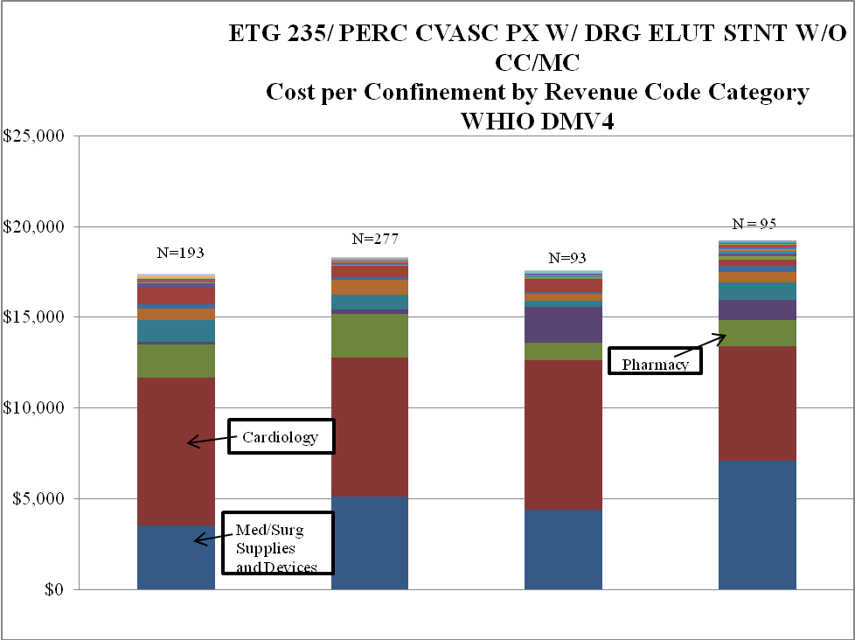
To further elucidate the facility component “Med/Surg Supplies and Devices”, a review of revenue codes particular to only this area was conducted for four high volume facilities (see Figure 13). As previously described, these coding descriptions which were the most granular available in the data mart, did not reveal to physicians which decisions did not add value. The disparate comparisons seen in Figure 13 suggest that there is significant variation in coding between hospitals that confounds comparing physician decision-making and cost at one facility versus another by claims alone.
Figure 13
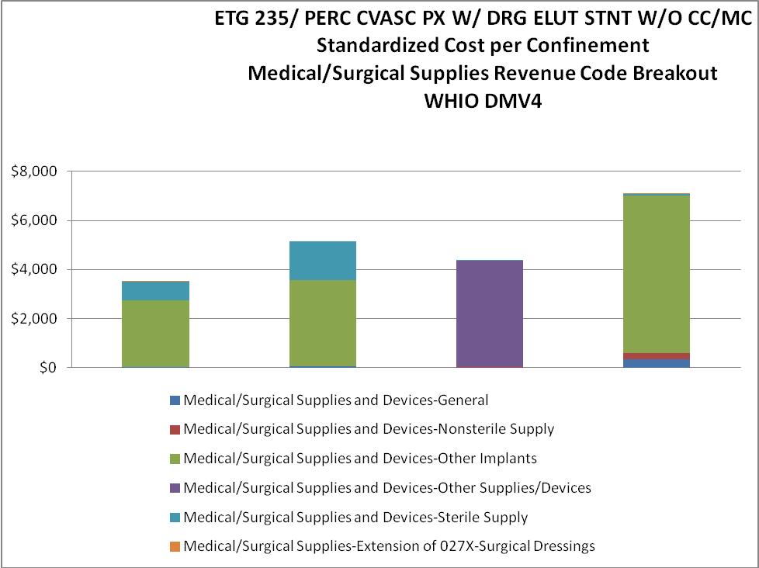

Cardiology Conclusions
Study participants concluded that while large differences between facilities in total standard cost could be documented, the level of detail available in claims data could only direct physicians to broad areas of cost that were not intuitive to physicians, and did not provide information on which physician orders did not add value. Other than reducing length of stay, which may correlate stronger with the time of delay to presentation, it was not clear how physicians would reduce cost.
Aside from the cost issues, cardiologists presented that some patients who received angioplasty did not fully understand the goals of the procedure and what can and cannot be expected. According to a study in the Annals of Internal Medicine, patients who had been consented for stenting (Percutaneous Coronary Intervention) appeared to believe that the procedure would help their chest pain, prospective risk of heart attack and mortality, when in fact only the likelihood of chest pain was impacted. For a broad variety of decisions in health care, this finding raises the important question of whether the patient has knowledgably chosen what they want in their care.
The Cardiology Study Group reported the following observations and recommendations:
Observations
- The cardiologist receives about 10% of the resources used for many evaluations, but authorizes payment for somewhere around 80% of total resources.
- There appears to be variation in the amount of resources used which could be a consequence of variable physician choices, clinical risk of the patient, time lapse from symptom onset to presentation, patient choice and coding inaccuracies but the source or sources of variation cannot be identified from the data.
- There is a significant employer role in messaging to the employee and adopting “intelligent” benefits design.
- What physicians do in hospitals may not be, perhaps probably cannot be, captured with sufficiently discrete granularity in claims for the physician to know what action produces the highest value when examining claims data alone.
- Hospitals may code differently from one facility to another. These services often amass the highest and most variable costs which make it essential that physicians understand those differences to avoid no value added choices in diagnosis or treatment.

Recommendations
- If physicians are going to change the way we care for patients based on claims data, continued maturation must happen to achieve reliable attribution, clinical risk adjustment, and outcomes. Making changes without reliability in these data elements may have the unintended consequence of patient harm, unintended additional cost, or incorrect assessment of who is achieving the highest value care.
- Better agreements are needed between patients and their doctors when comforting the patient with clinical futility and their family. Specifically, physicians need to know the patient’s and family’s wishes about what the doctor should do next when clinical care is futile. We have work to do in having our patients know their options and making choices about their care, including at end of life.
- AUC may enhance evidence-based choices and reduce variation. A dash board including resource use and clinical data, shared decision making and AUC should be available at the site of care.

Behavioral Health
Psychiatrists, primary care physicians, employers, organized nursing and senior groups came together to seek higher value behavioral health care. ETGs in Psychiatry were reviewed and Mood Disorder, Depressed and Mood Disorder, Bipolar were selected by the study group because of their prominence in this analysis, and the presence across multiple providers in Wisconsin communities (Figure 14). Variation in diagnosis and treatment was suspected by the data study team.
Figure14:
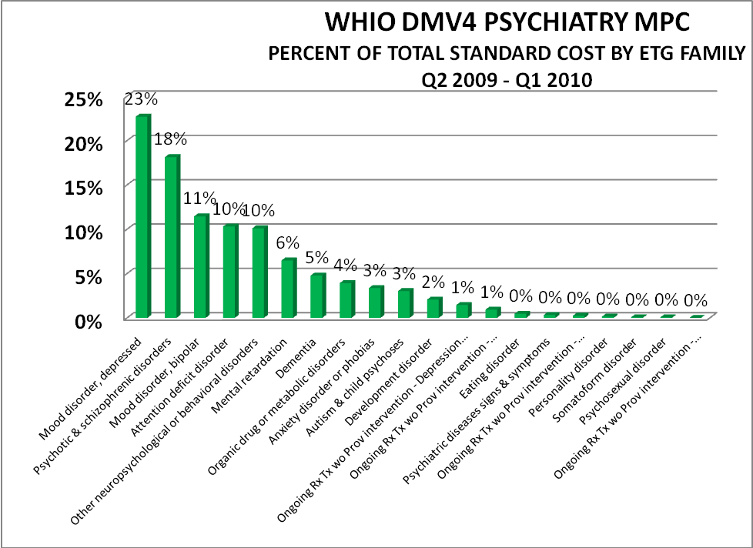

The top behavioral health ETGs are distributed among payers as seen in Figure 15. This distribution is especially prominent with the dual eligible population defined by simultaneous Medicare and Medicaid eligibility. This dual eligibility requires significant resources and has received specific attention in the Patient Protection and Affordability Care Act (PPACA).
Figure 15
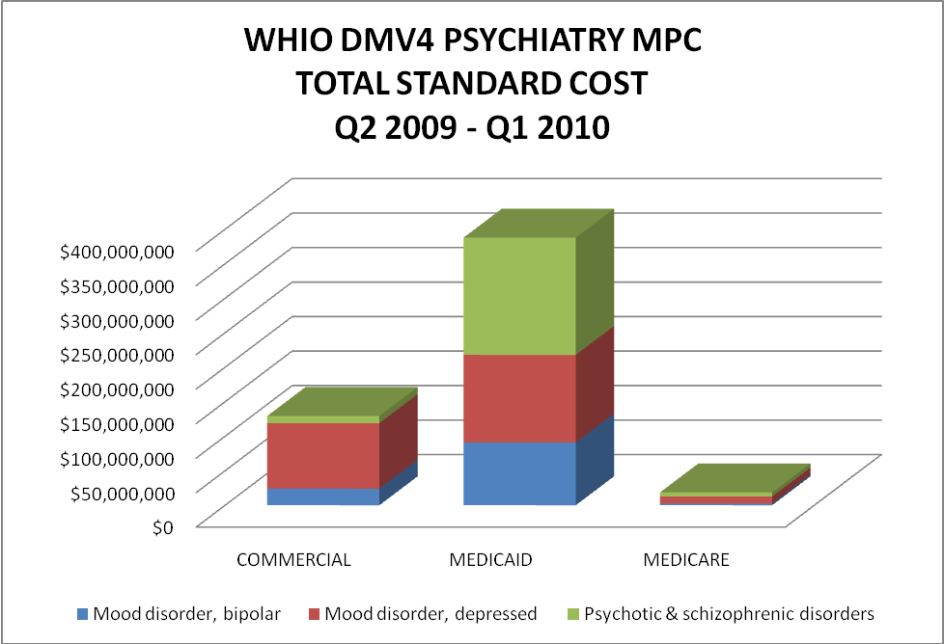

As found in WHIO DMV4, dual eligibles are attributed first to Medicaid and are approximately 8 % of the total by population (Figure 16). This high needs population will need increasing management of expense and was identified by Health and Human Services Secretary, Kathleen Sebelius in her letter to Governors on February 3, 2011:

…we are focused on how to help States provide better care and lower costs for so called “dual eligibles,” seniors and people with disabilities who are eligible for both Medicaid and Medicare. These individuals represent 15 percent of Medicaid beneficiaries but nearly 40 percent of all Medicaid spending. This population offers great potential for improving care and lowering costs by replacing the fragmented care that is now provided to these individuals with integrated care delivery models.

Figure 16
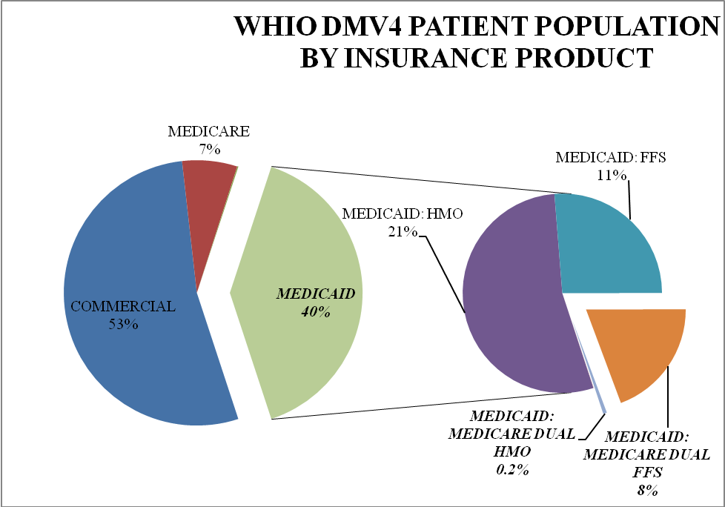

The distribution of medical resource utilization is seen in the next two pie graphs, where in a commercial population, most will not spend more than $25,000 per year (Figure 17). By contrast, in the dual eligible population, there is a distribution across very expensive cohorts (Figure 18).

Figure 17
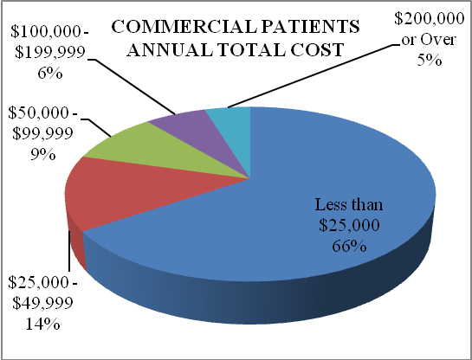

Figure 18
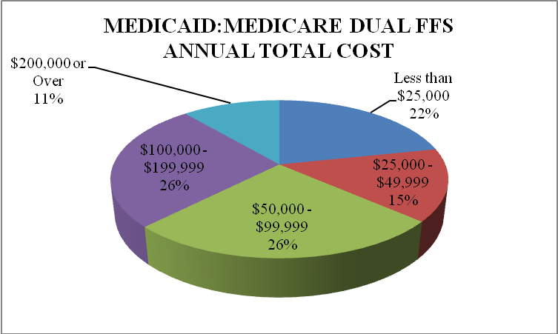
It is the intense need for coordination to stabilize multiple health conditions and this concentrated resource investment that has motivated several initiatives to manage the dual eligible population more carefully including the significant long term care costs, some of which is designated as Facility Inpatient (Figure 19). Many of these resources are invested in psychiatry and neurology. Psychiatry management and decision making appears to be part of any effective solution for dual eligibles and other Medicaid beneficiaries.
Figure 19
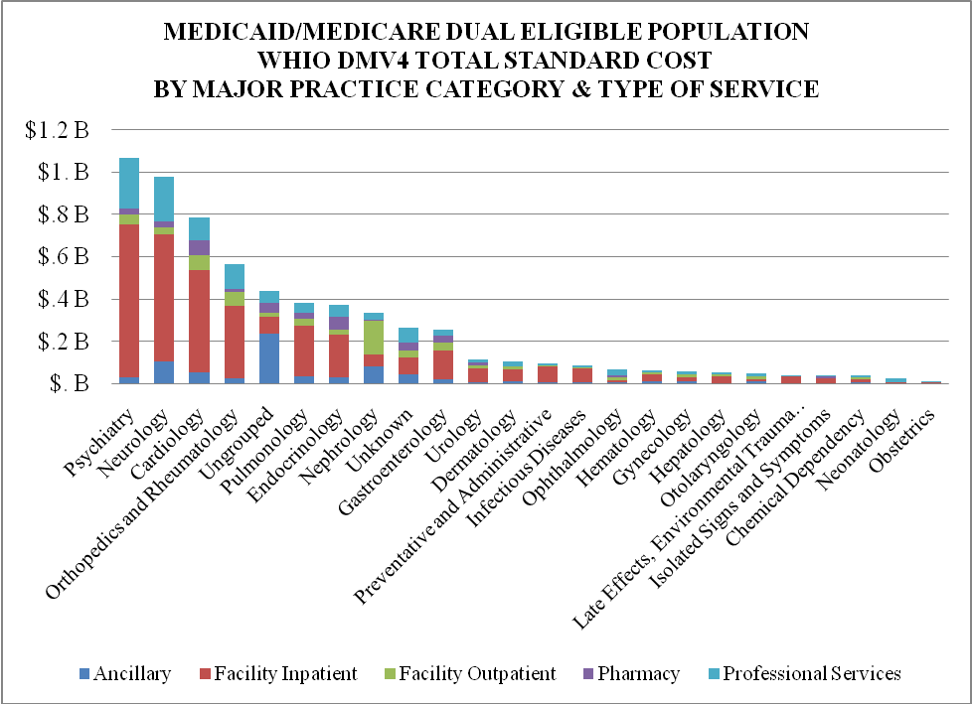

Further review has shown that whereas other procedures in other MPCs have dominant facility costs, the psychiatry MPC has costs heavy in pharmacy, fully 22% as seen in Figure 20. While Professional Services are 29% of this MPC, ultimately only 8% are attributable directly to psychiatrists. Much of the rest of this service is in the hands of non-physicians including social workers, psychologists and other non-physicians (Figure 21).
Figure 20
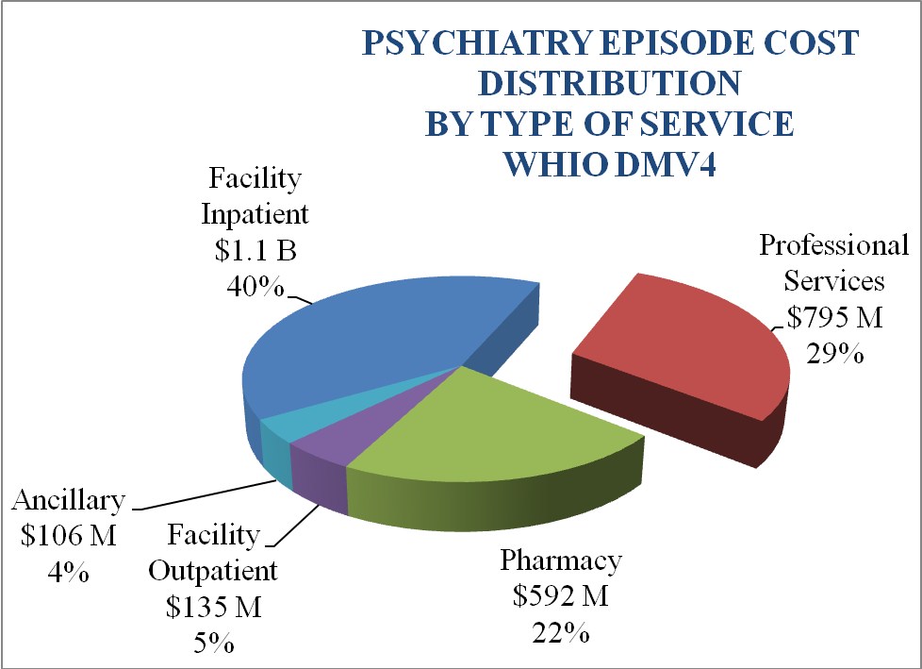

Figure 21
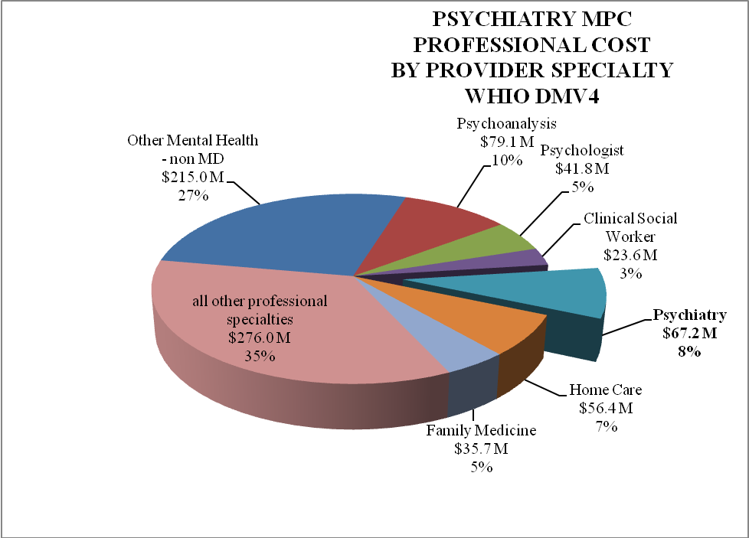

ETG Focus: Mood Disorder, Depressed
In the study of depression, the behavioral health data investigation group found that nearly half of all resources used were for pharmacy in DMV2 and 38% of all resources were for professional services (Figure 22). A substantial proportion of care for depression appears to be provided by non-physicians (Figure 23). It is unknown whether this is the result of carefully crafted models of care or if this is the direct consequence of insufficient psychiatrists available to take care of Wisconsin citizens. Rural and urban environments consistently issue concerns about insufficient behavioral health capacity.
Figure 22:
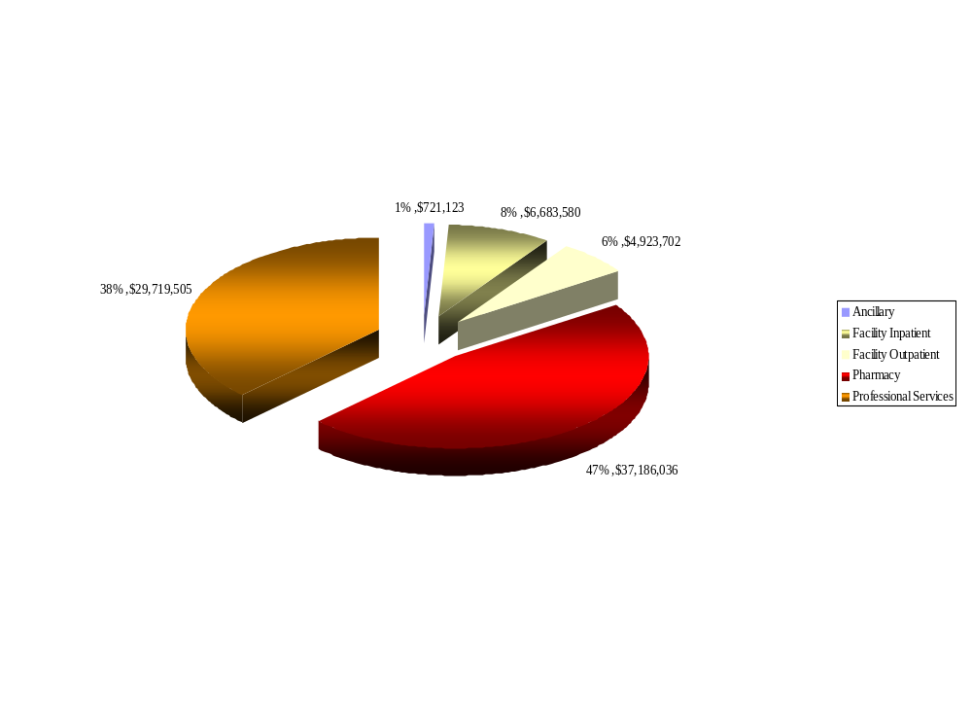
Mood Disorder, Depressed: Second Year of DMV2

Figure 23
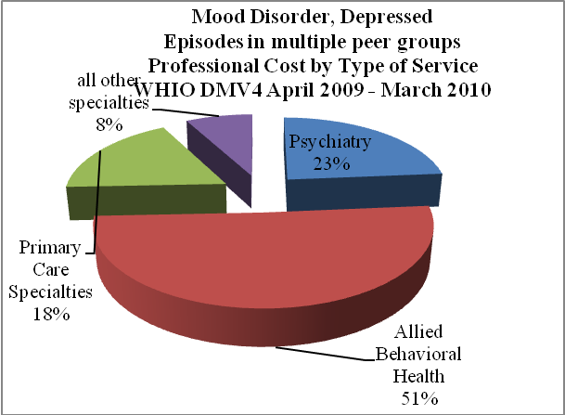
For the medications that are prescribed within the psychiatry MPC, both brand name and generic medications are available. One of the challenges for prescribers is determining which of the brand name medications could be suitably replaced either by a less expensive brand name medication or by generic medications where such a substitution would provide an equivalent treatment but with cost savings (Figure 24).
Figure 24
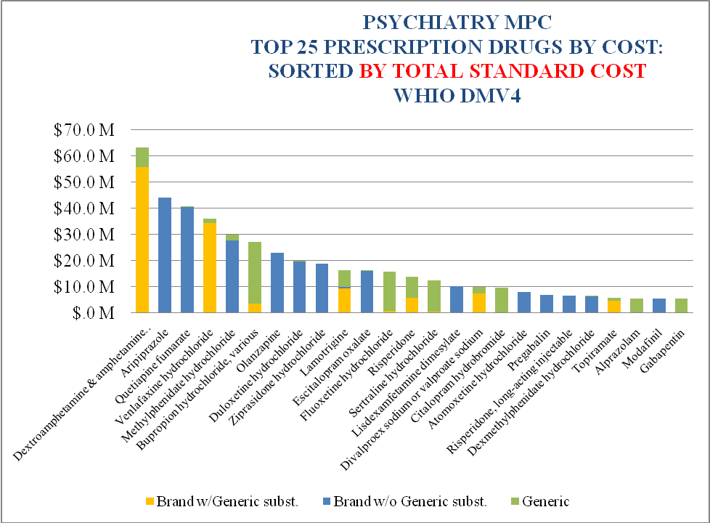

ETG: Mood Disorder, Bipolar
According to a study in Archives of General Psychiatry, the prevalence of visits for bipolar disorder has increased dramatically over the last 15 years. For youths, the percentage of visits related to a bipolar disorder diagnosis rose from 0.42% in 1994-1995 to 6.67% in 2002-2003. Among adults that percentage rose from 4.77% in 1994-1995 to 6.58% in 2002-2003.
While pharmacy costs for depression consume a respectable 22% of all costs, these are exceeded for the diagnosis of Mood Disorder, Bipolar with 35% of the total standard cost used for pharmacy. (Figure 25)
Figure 25
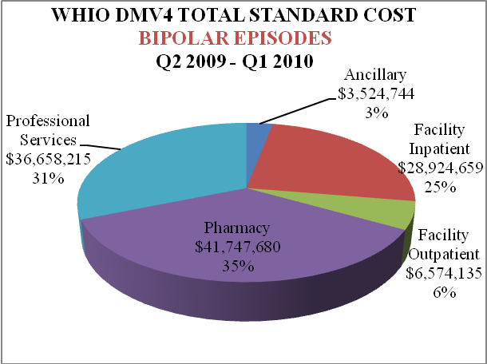

When pharmacy is studied by class, antipsychotic use is the most costly category. Within this class, there is a large difference between Medicaid and Commercial beneficiaries’ use of these agents (Figure 26).

Figure 26
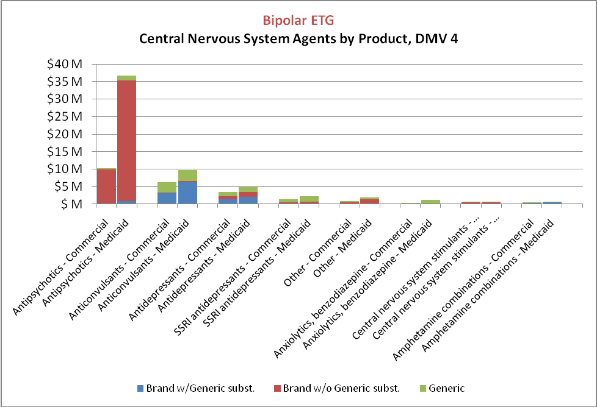
Further analysis of specific antipsychotic medications demonstrates that much of the use these agents in bipolar treatment is found within Medicaid (Figure 27). Psychiatrists on the study team asked one another if the brand name agents that were chosen were required or if they together believed that less expensive generic or less expensive brand name agents would be appropriate in this circumstance. Because of the significant cost and use of atypical antipsychotics, it is important that physicians verify that these agents are the best choice in a treatment plan.
Figure 27
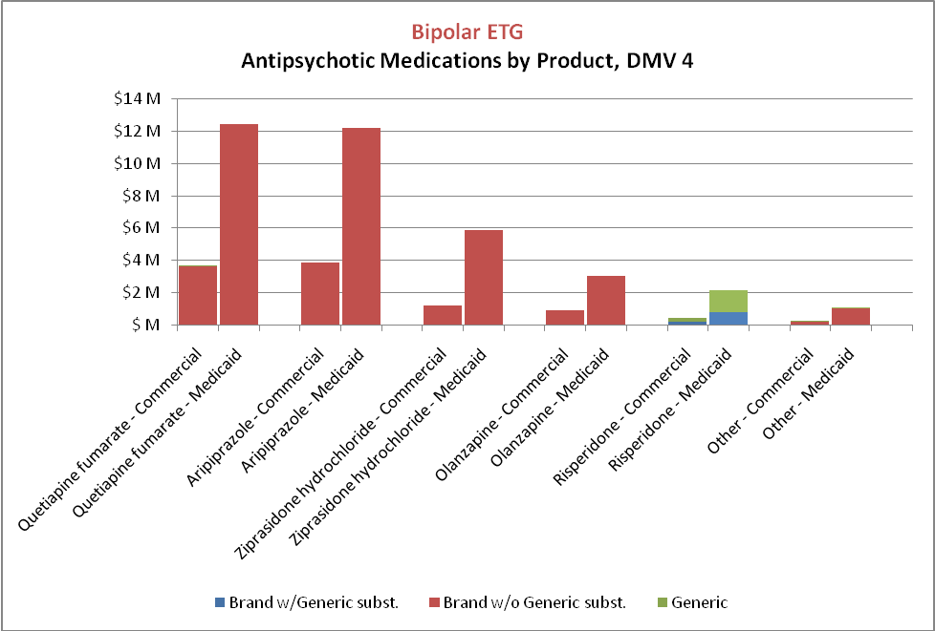

Behavioral Health Conclusions
The psychiatry group reported the following observations and recommendations:
Observations
- There is increased prevalence of visits for bipolar for both adults and children. Variability in the selection of patients for treatment of bipolar is suspected. AUC may be helpful in the proper diagnosis and treatment of bipolar. A project sponsored by the Nebraska-Ohio-Wisconsin (NOW) coalition is addressing this opportunity.
- Participants were concerned that reimbursement for outpatient psychiatry, seen over the last decade, may be eroding access to outpatient treatment of psychiatric illnesses.
- New models like patient-centered medical homes with behavioral health may be necessary to address severe physician workforce imbalances. Primary care is sometimes practicing beyond its zone of comfort because there are not enough mental health physicians available.
Recommendations
- Wisconsin needs sufficient access to psychiatrists and in the appropriate outpatient locations.
- Use of pharmacy resources for depression and bipolar needs to be evaluated by psychiatrists to assess if opportunities exist to achieve treatment goals while using less expensive alternatives.
- Because Medicaid is a disproportionate payer, careful coordination with Medicaid will be required to assure that patients receive excellent treatment with the most cost efficient medications to achieve this goal.

Gastroenterology
After reviewing the data, the gastroenterology study team identified the ETG of Inflammation of Esophagus, Without Surgery as their focus. Analysis of this area quickly identified that a targeted initiative around pharmacy utilization would address much of the opportunity to enhance value, and a more intensive analysis was not necessary.

ETG: Inflammation Of Esophagus, Without Surgery
As seen in Figure 28, the resources dedicated to pharmacy for this ETG were about 34%, while the resources that were used for the gastroenterologists were about 6% of the ETG total standard cost.
Figure 28
Inflammation of Esophagus, Without Surgery: Second Year of DMV2
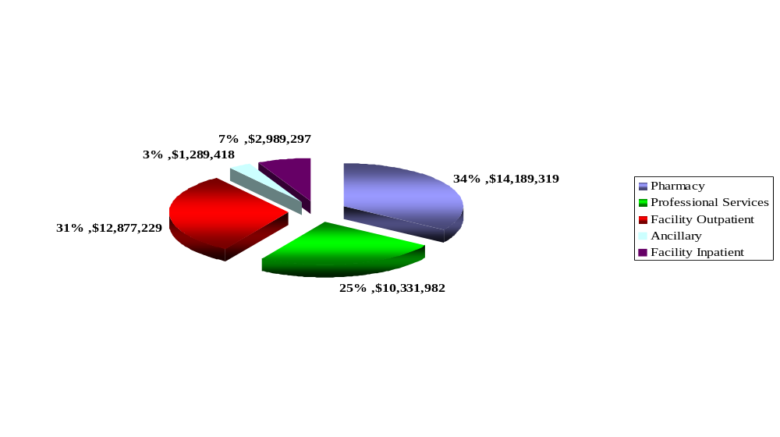

Further investigation revealed that these significant pharmacy investments were ultimately identified to be almost entirely proton pump inhibitors, including the colloquially identified “purple pill.”

Gastroenterology Conclusions
The gastroenterology study group made the following observations and recommendations after completion of their review
Observations
- The gastroenterologist is about 6% of the cost for this area that has both isolated medical management and other cases that require procedures and medical management.
- Pharmacy costs are a surprisingly high proportion of the total ETG. Although these are relatively older agents with generic alternatives available, generics are not often prescribed.

Recommendations
- Step down therapy is a treatment strategy where after cure is achieved in initial treatment, the patient is placed on a reduced amount of medication or discontinued altogether. Step down therapy appears not to be prominent in the use of these pharmacy agents but should be further studied by the gastroenterology and other physician community. If this is true, there may be significant dollar savings to be realized by simply not having patients continue these agents if this is believed to be the best care for patients.
- Dialogs between organized gastroenterology and Wisconsin based insurers quickly identified several opportunities for reducing pharmacy costs.
Conclusion: New Model Of Care Delivery
The key learning from this project was that physician led clinical and resource comparisons with shared decision making is a new model of patient centered, resource sensitive care delivery. Understandings from this data analysis combined with established and nascent specialty registries and guidelines provide important policy opportunities:
- Physicians can deliver a sophisticated medical decision, informed by registry clinical data about relative benefits and relative risks that are increasingly patient specific, providing the best advice available to the patient for them to use in a shared decision. Prior authorization processes cannot provide this level of sophistication.
- This model restores clinical decision making to the physician and patient, using specialty crafted AUC/guidelines instead of proprietary “benefits managers” that seek to control utilization, devoid of clinical expertise or judgment.
- This platform offers a transition from fee for service payment toward rewarding the informed and shared choice of who will and who will not benefit from a considered diagnostic test or treatment, with maturation of decision support tools as choices are captured in electronic health records and later studied.
- The model advances reimbursement toward payment for clinical care of populations, like stabilizing chronic illness, beyond just the patient in clinic. These physician behaviors will be required for ACO or other increased physician financial risk payment platforms.
- Fiscal risk under this model will be partitioned into discrete segments. This model will allow physicians to manage clinical risk and the 70-80% of resources that they control by their ordering habits. Insurers will need to continue to manage actuarial risk, and will be able to incrementally withdraw from managing clinical decisions.
- Already, AUC for radiology through commercially available tools are displacing radiology benefit managers. The described model, however, extends beyond AUC alone.
- In addition to the continuous improvement of practice, real time changes in decision making and learning, with retrospective reflection at regular periods, may be eligible for maintenance of certification and ultimately contribute to maintenance of licensure.
- Specialty and primary care collaborations across regions can cooperatively improve care across a region, with more rapid spread that one hospital or organization at a time. These alliances encourage new team behaviors for a shared multiple dimension measured goal of better care.
- Physicians working across geographies like states could set the standard for “medical necessity,” by using AUC to assess utilization of resources across large regions. Without this physician action, and in the presence of observed variation in use of resources or simple unsustainable expense, CMS appears compelled to act. In November of 2011, CMS announced the Recovery Audit Program Prepayment Review Demonstration that would authorize holding payment for angioplasty and 14 other DRGs pending a determination of “medical necessity” in several states.

SMARTCare

The concrete example of this model is SMARTCare (Smarter Management and Resource Use for Today’s Complex Cardiac Care Delivery) developed in concert with cardiologists in Wisconsin utilizes the robust and prescient tools and registries of the American College of Cardiology. SMARTCare expresses the model and can provide a proof of concept for other specialties to adopt for enhanced site of care shared decision making. This project provides the practitioner at the site of decision making with a dashboard of data that would allow 4 components of data to address the needs of the patient. This work is being memorialized into a new model of resource, clinical quality, patient specific, patient informed care currently under further development.
In a single point of service dashboard, these components will include:
- Benchmarking resource use data from WHIO and/or Medicare claims data, with sufficient safeguards against erroneous data, compared to others in their practice, their city, and their state.
- Benchmarking of clinical data, most particularly AUC for several procedures, which would allow the practitioner to see how their measure of “AUC not met” compared to others in their practice, their city, their state and the nation.
- Formal shared decision making that provides patient specific complication rates, and likely benefits.
- AUC that can be scored for how closely the decision in the patient specific circumstance comports with the AUC. Once aggregated scores and physician exceptions are catalogued, maturation of AUC can be undertaken.

Summary
Our data study groups agreed that claims data alone was insufficient to instigate a change in practice, especially one which may impact the care of patients. This conclusion was reached principally because some of the most important features of care quality cannot be evaluated when claims data is viewed in the absence of clinical information (e.g. patient access to care, clinical risk, onset, outcomes, etc) from the medical record. Conducting this investigation with purchasers, consumers and physicians was a key feature of arriving at stronger mutual understandings and commitment to make a collective impact. From this collaboration, a new model of clinical decision making was described that combined resource use, clinical registry and shared decision making that leverages claims data to enhance the value of health care.
Despite the concerns raised by the group, there are exceptionally important lessons that can be learned from the claims data review. Key directives agreed upon by our reviewers include:
- Employer representatives and consumers working directly with practicing physicians in state and national specialty leadership to develop a path to higher value health care.
- A need for physicians to be more aware of the relative cost of an episode of care. They also need to be more aware of the relative costs of resources, where two or more equally suitable options exist so that the physician can make the highest value decision.
- The responsibility of physicians to advance appropriate use criteria (AUC) (e.g. treatment guidelines aided by computer decision support tools) to more accurately discern between patients who will and will not benefit from a considered procedure.
- Where a patient is thought to be appropriate for a procedure or investigation, physicians need to reduce variation in resource use between physicians to accomplish an excellent outcome.
- Consumers must be a partner in keeping themselves well.

Mixed Results Of Opportunity And Misconception Still Offer The Potential To Enhance The Value Of Care
These results do suggest that physicians can positively use claims data to review resource use and identify opportunities to enhance the value of care. The significant variations seen in these results however, are not sufficiently discrete for physicians to make substantive changes in practice especially when patient safety and mortality are at risk. Yet, if physicians have these data available, they should use this information to make cost sensitive decisions. A lack of awareness of these findings may put some patients at risk for less affordable care or eliminate access to care solely as a consequence of higher cost.
However appealing, if these data, which are confusing to physicians, are presented to the public, it remains unproven whether patients will be helped or further confused by tools designed to classify individual physicians with “quality” or “efficiency” metrics. Evaluating such data also creates additional questions:
- Will such data only serve to raise questions about all patient physician relationships?
- Do such evaluations adequately reflect the reality of team-based care?
- Can the data be made sufficiently reliable to earn the trust of prospective publishers and ultimately of the consumer?
If these questions cannot be satisfactorily answered, hasty presentation of this data could risk the public’s trust for a generation at a time in which we desperately need to improve the cost and safety of care. However, it is no longer acceptable that the physician practice without being constantly aware of the resource impact of their decisions – to forget this is to risk access of care for many.
These mixed results of opportunity and misconception and the diminishing affordability of care strongly suggest that physicians or their agents need to be proactive in improving the affordability of care by learning what they can from claims data. These efforts may have significant implications on the development of a value metric for Medicare as early as mid 2012 and for all of us as consumers who need to use “value” assessments while seeking a physician to care for ourselves or our loved one. Finally, in combination with clinical registry data, resource use data in a shared decision making platform evolves a powerful new path for better value based, patient centered choices in health care.
Appendix A: WHIO Health Information Organization Members And Subscribers 2011
Left column reflects initial stakeholders. Middle column lists data contributors and the right column includes data subscribers

WHIO Founding Member Organizations |  | WHIO Members (non-founding health plans who contribute data) |  | Subscribers
The Alliance |  | Dean Health Systems |  | Aspirus
Anthem Blue Cross Blue Shield of Wisconsin |  | Group Health Cooperative -South Central Wisconsin |  | Aurora Health Care
Greater Milwaukee Business Group on Health |  | Gundersen-Lutheran Health Plan |  | Bellin Health
Humana, Inc. |  | Health Tradition Health Plan |  | Prevea Health Care
United Healthcare of Wisconsin |  | MercyCare Insurance Company |  | ThedaCare
WEA Trust Insurance |  | Network Health Plan |  | UW - Population Health
Wisconsin Collaborative on Healthcare Quality |  | Physicians Plus Insurance
Wisconsin Department of Employee Trust Funds |  | Security Health Plan
Wisconsin Department of Health |  | Unity Health Plans
Wisconsin Department of Health
Wisconsin Hospital Association
Wisconsin Medical Society
Wisconsin Physicians Service Insurance Corporation

Appendix B: Comparing ETGs with CPT
OptumInsight has identified about 600 Episode Treatment Groups in version 6 that bundle costs together. But physicians are accustomed to thinking about the care associated with a particular CPT code. The analysis was focused on identifying a high volume CPT code with large ETG expense in each category. For some CPT codes like 27447, few other ETGs contain this CPT code. For other procedures, however, like arthroplasty 29881, this procedure will be found in a couple of ETGs. Specifically, almost all of CPT code 27447 is contained within ETG 676, but 28991 is a CPT code found within at least 3 ETGs. Ultimately it has been important to look for episodes that contain a specific CPT code of interest. ETG analysis alone without limiting to the study of a CPT code produces an ETG analysis that contains several dissimilar CPT codes with corresponding different resource use needs.

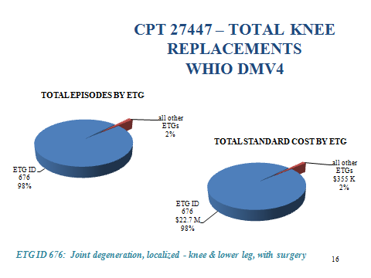

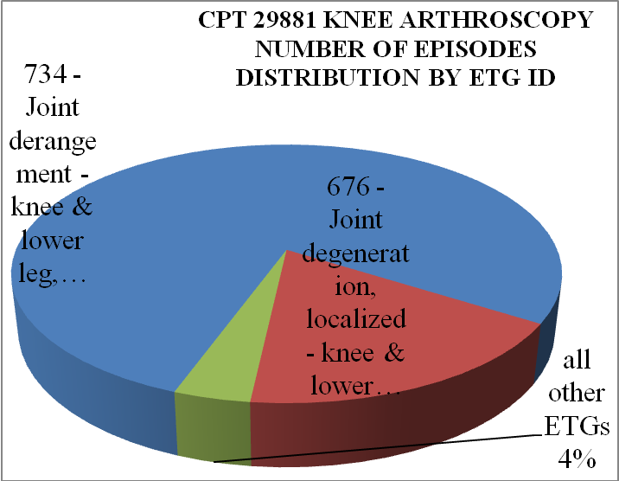
Appendix C

ETG Evaluation
Full episodes to be used to evaluate physicians require that certain parameters are met:
- Episodes must reside in a 12 month period,
- Episode is complete within that 12 month period, (i.e. does not start before the 12 months or end after the 12 month window),
- Episode contains what are thought to be required elements, like a surgical CPT code and an inpatient hospitalization for major surgery,
- A responsible provider has been assigned,
- Episode identified actually has a designated peer group for comparison, for instance a neurosurgical case does not have a defined neurosurgical peer group.

The result of subjecting claims to these tests is that only 11% of episodes are used for evaluation. 89% of all ETGs are disqualified by these exclusions for use in analysis of Episode cost:
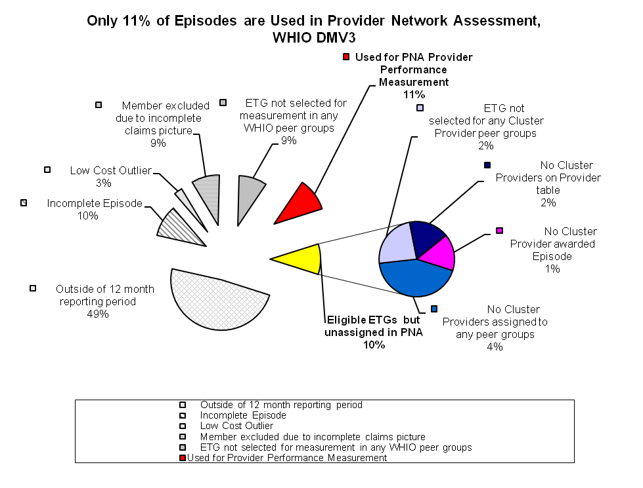
Appendix D
ETG from DMV 2 “Joint Degeneration, Localized, of the Knee and Lower Leg, With Surgery
FAMILY | ETG | Number of Episodes | Total Std Cost | Total Std Cost per Episode | Total Billed | Total Billed per Episode | Inpatient Admits | Inpatient Admits per 1000 Episodes | Inpatient Days
Joint degeneration, localized | Joint degeneration, localized - back, with surgery | 11,580 | $ 138,793,435 | $ 11,986 | $ 364,464,340 | $ 31,473 | 3,102 | 268 | 12,182
Joint degeneration, localized | Joint degeneration, localized - knee & lower leg, with surgery | 5,794 | $ 123,511,678 | $ 21,316 | $ 260,852,138 | $ 45,019 | 5,262 | 908 | 22,506
Joint degeneration, localized | Joint degeneration, localized - back, w/o surgery | 66,387 | $ 108,853,476 | $ 1,640 | $ 194,148,489 | $ 2,924 | 1,028 | 15 | 9,370
Joint derangement | Joint derangement - knee & lower leg, with surgery | 9,709 | $ 84,509,947 | $ 8,704 | $ 193,379,293 | $ 19,918 | 221 | 23 | 990
Joint degeneration, localized | Joint degeneration, localized - neck, w/o surgery | 38,111 | $ 56,532,706 | $ 1,483 | $ 102,125,191 | $ 2,680 | 277 | 7 | 2,354
Joint degeneration, localized | Joint degeneration, localized - thigh, hip & pelvis, with surgery | 2,476 | $ 55,731,902 | $ 22,504 | $ 128,332,096 | $ 51,820 | 2,687 | 1,085 | 11,525

Chart Pack

Figure 1
Figure 2
Figure 3
Figure 4
Figure 5: Type of Service for 27447—Arthroplasty, knee, condyle and plateau; medial and lateral compartments with or without patella resurfacing (total knee arthroplasty)

Figure 6
Figure 7
Figure 8: CPT 27447/ETG ID 676 – Knee Replacement Episodes, Single Knee, Single Admission, Severity Level 1, w/responsible provider, WHIO DMV4
Figure 9
Figure 10
Figure 11
Figure 12
Figure 13
Figure 14
Figure 15
Figure 16
Figure 17
Figure 18

Figure 19
Figure 20
Figure 21
Figure 22: Mood Disorder, Depressed, Type of Service, DMV 2
Figure 23
Figure 24
Figure 25
Figure 26
Figure 27
Figure 28: Inflammation of Esophagus, Without Surgery: Second Year of DMV2

Appendix B

Appendix C

https://www.cms.gov/NationalHealthExpendData/downloads/highlights.pdf
http://www.commonwealthfund.org/~/media/Files/Publications/Issue%20Brief/2011/Jul/1532_Squires_US_hlt_sys_comparison_12_nations_intl_brief_v2.pdf
http://ehbs.kff.org/pdf/2011/EHBS%202011%20Chartpack.pdf, exhibit 1
http://www.washingtonpost.com/wp-srv/politics/documents/american_journal_of_medicine_09.pdf
http://ehbs.kff.org/pdf/2011/EHBS%202011%20Chartpack.pdf, exhibit 10
http://ehbs.kff.org/pdf/2011/EHBS%202011%20Chartpack.pdf, exhibit 9
https://www.cms.gov/SustainableGRatesConFact/Downloads/medpacfinal.pdf
https://www.cms.gov/ReportsTrustFunds/downloads/tr2011.pdf, p. 68.
https://www.cms.gov/ReportsTrustFunds/downloads/tr2011.pdf, p. 71.
http://www.speaker.gov/News/DocumentSingle.aspx?DocumentID=241425
http://managedhealthcareexecutive.modernmedicine.com/mhe/article/articleDetail.jsp?id=46508
http://www.wisconsinhealthinfo.org/
http://www.apcdcouncil.org/state/map, accessed Oct 30, 2011
http://www.wisconsinhealthinfo.org/Presentation%20for%204-19-11%20WHIO%20CAP%20meeting.pdf, p 16, and Optum Communication, Standard Pricing, Feb 2, 2012
Commercial insurance is generally employer-based insurance most often for persons below the age of Medicare eligibility. Medicare is generally for persons over the age of 65 and in certain categories of disability. Occasionally individuals will be eligible for both Medicare and Medicaid as a consequence of multiple disabilities.
http://www.dartmouthatlas.org/
http://www.ingenix.com/content/attachments/Symmetry_EpisodeAttribution_WP_FINAL_112007.pdf
CPT - Current Procedural Terminology: CPT® is registered trademark of the American Medical Association
The Alliance (http://the-alliance.org/ ), personal communication and presentation to American Academy of Orthopedic Surgery, Oct 2010
Annals of Internal Medicine. 2010; 153: 307-313
http://www.hhs.gov/news/press/2011pres/01/20110203c.html
http://archpsyc.ama-assn.org/cgi/content/full/64/9/1032
https://www.cms.gov/apps/media/press/factsheet.asp?Counter=4170
http://www.ingenix.com/content/attachments/Symmetry_EpisodeAttribution_WP_FINAL_112007.pdf
CPT - Current Procedural Terminology: CPT® is registered trademark of the American Medical Association
CPT 27447: Arthroplasty, knee, condyle and plateau; medial AND lateral compartments with or without patella resurfacing (total knee arthroplasty)
CPT 29881:Arthroscopy, knee, surgical; with meniscectomy [medial OR lateral, including any meniscal shaving]
ETG 676: Joint Degeneration, Localized – knee and lower leg, with surgery ETG 734 Closed fracture or dislocation, lower extremity, w/o surgery

